CUSTOMER SEGMENTATION ANALYSIS - IMAGES AND OUTPUTS
STEP 2 – LOAD DATASET
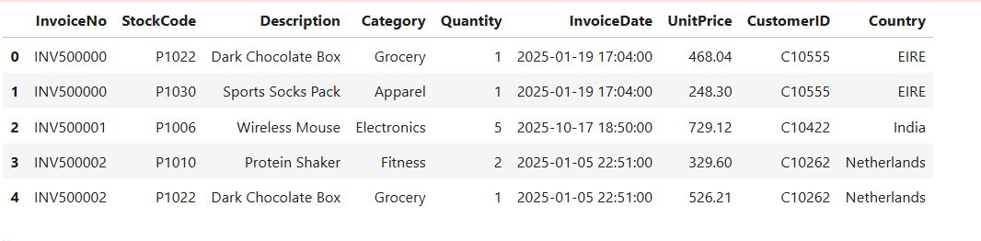
This is preview of first five rows after loading the data.

STEP 6 – EXPLORATORY DATA ANALYSIS(EDA)
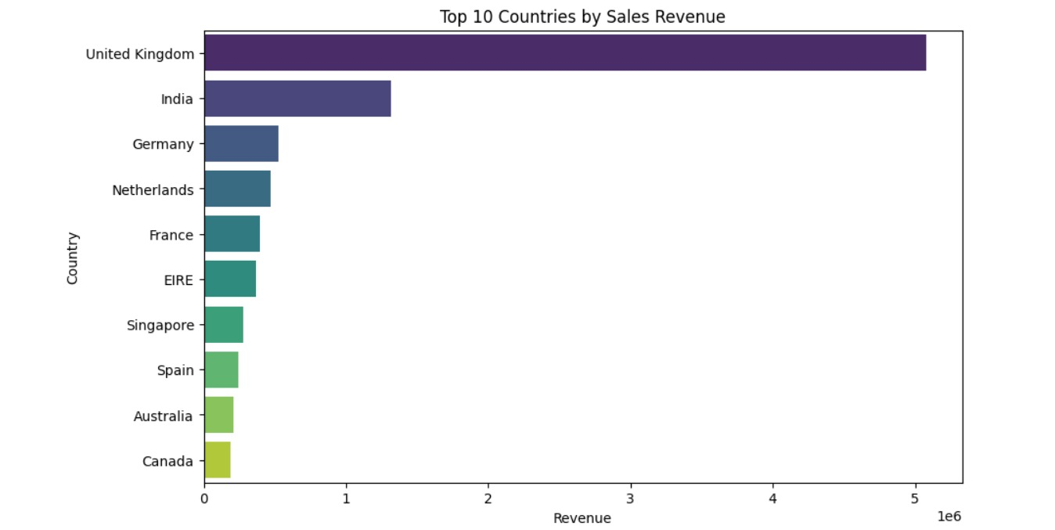
The analysis shows that the United Kingdom overwhelmingly leads in sales revenue, far ahead of all other countries. Meanwhile, India and Germany contribute noticeably but remain much smaller markets, highlighting the UK’s dominance in overall business performance.
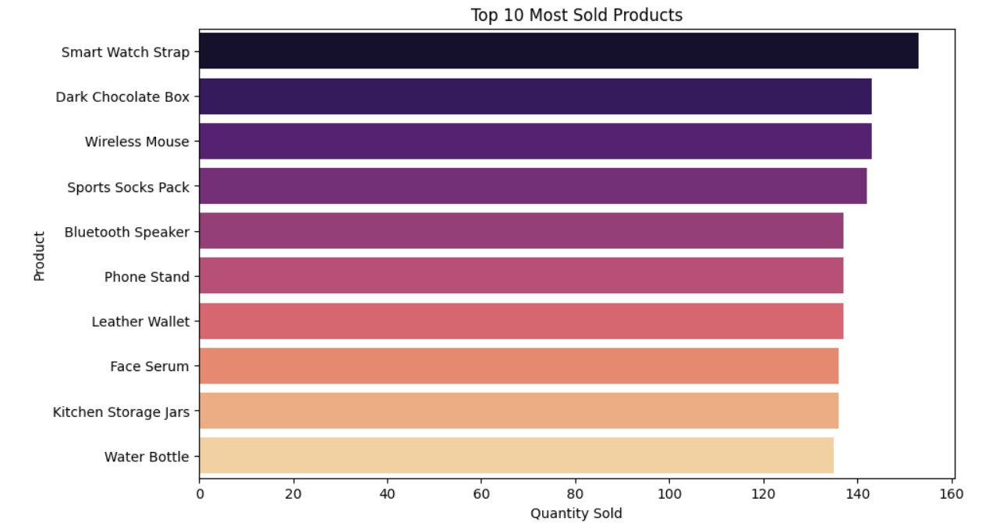
The analysis reveals that the Smart Watch Strap is the most sold product, showing strong customer preference for tech-related accessories. Other items like Dark Chocolate Box and Wireless Mouse also perform well, indicating a mix of lifestyle and electronic products driving overall sales.
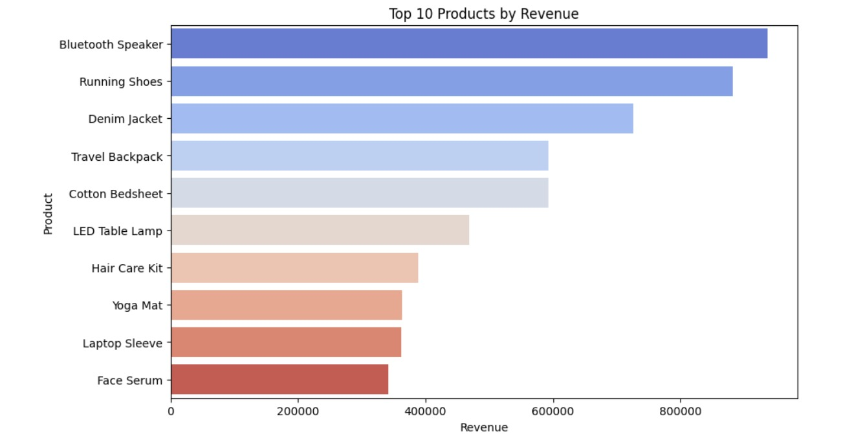
The analysis highlights that Bluetooth Speakers generate the highest revenue, making them the most profitable product in the dataset. In contrast, items like Face Serum and Laptop Sleeves contribute much less, showing that tech and lifestyle products dominate overall revenue performance.
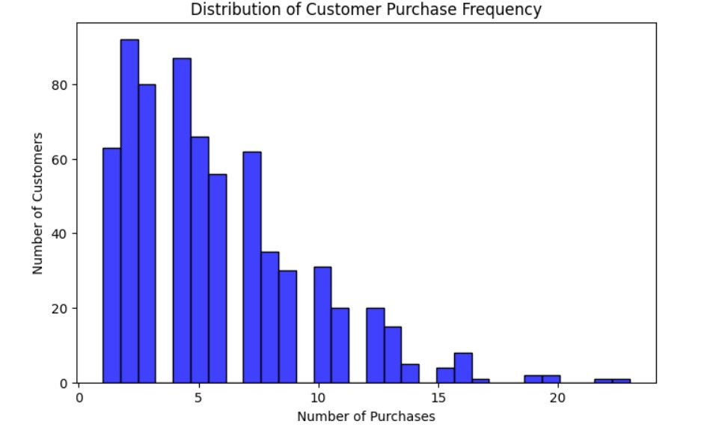
The chart shows that most customers make only 1–5 purchases, indicating a large base of occasional buyers. In contrast, frequent buyers are rare, highlighting the importance of nurturing loyal customers to boost long-term revenue.
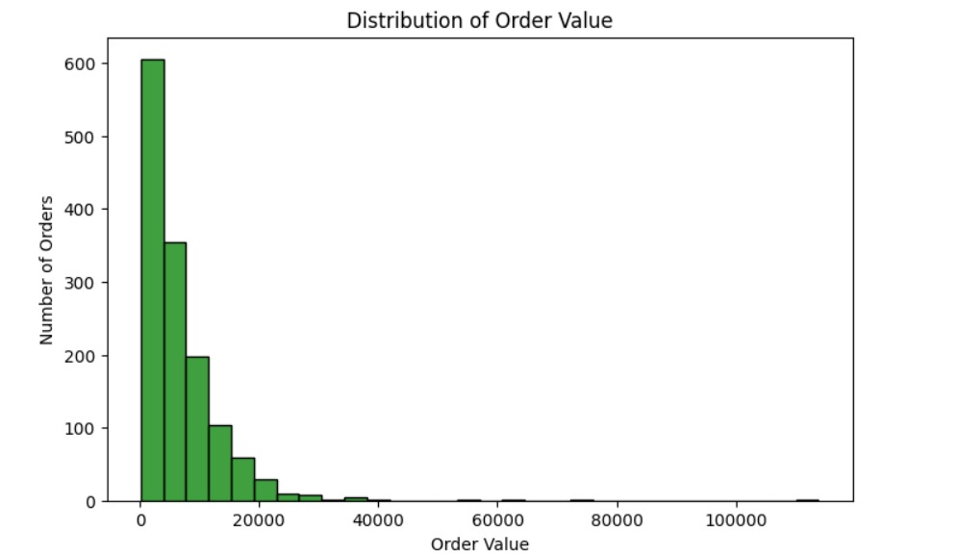
The chart shows that most orders are of low value, concentrated near the lower range, which reflects small and frequent purchases. In contrast, high-value orders are rare, indicating that large transactions contribute only a small portion of overall sales.
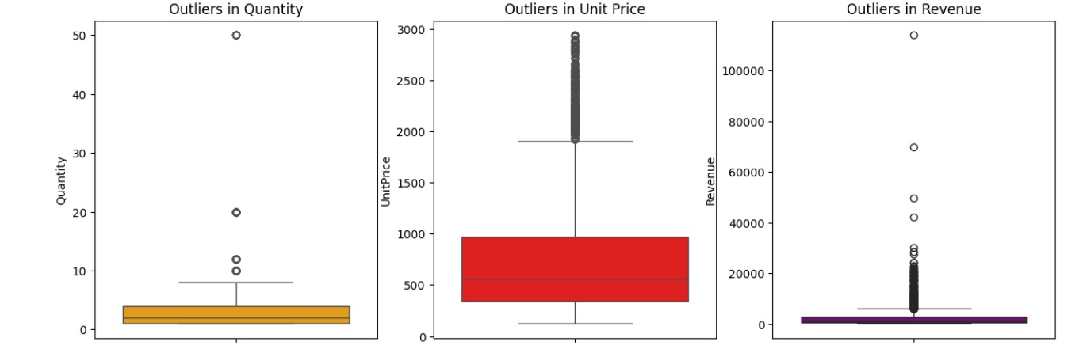
The box plots reveal that extreme outliers exist across all three metrics, with unusually high values in quantity, unit price, and revenue. These anomalies suggest rare but impactful transactions that may distort averages and require careful handling in analysis.
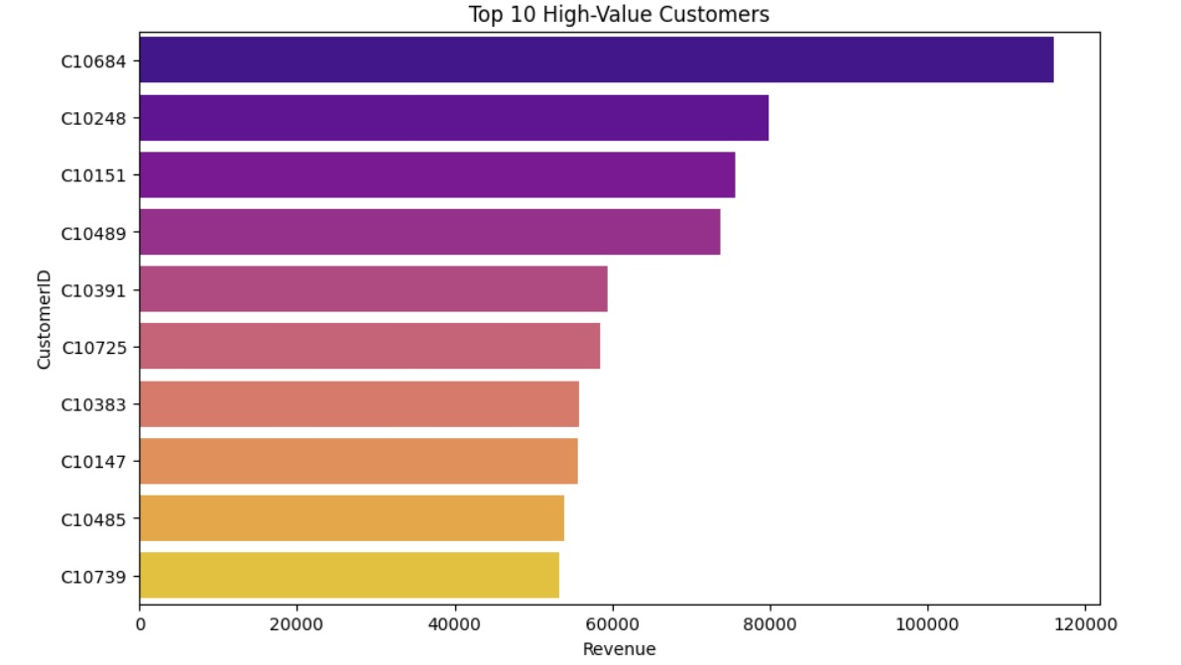
The chart shows that Customer C10684 contributes the highest revenue, standing out as the most valuable client in the dataset. Other customers like C10248 and C10151 also generate significant sales, but their impact is smaller compared to the top customer.
STEP 7 – CUSTOMER SEGMENATTION USING K - MEANS

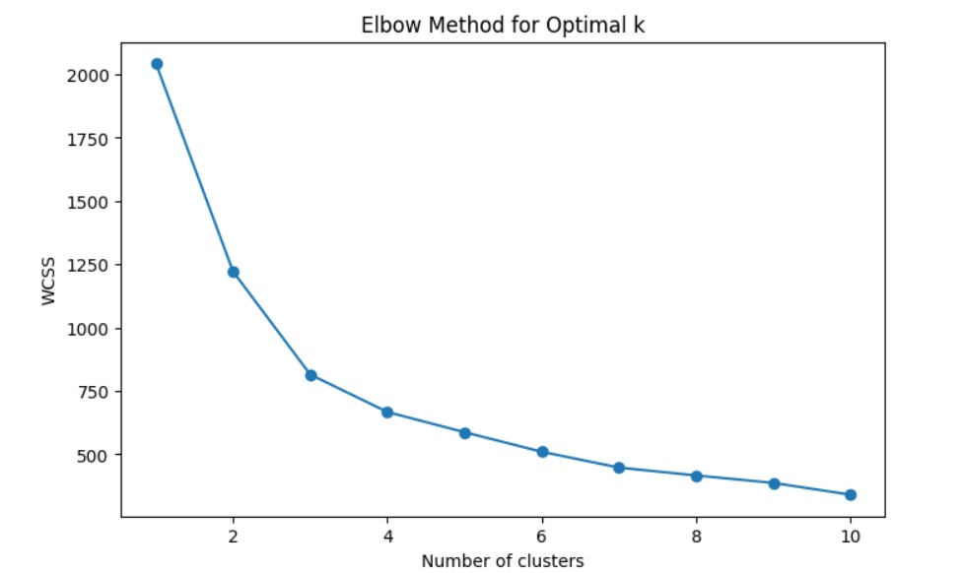
The graph shows that the WCSS drops sharply until k=3, after which the curve flattens, forming a clear “elbow.” This indicates that 3 clusters provide the best balance between compactness and simplicity for customer segmentation.
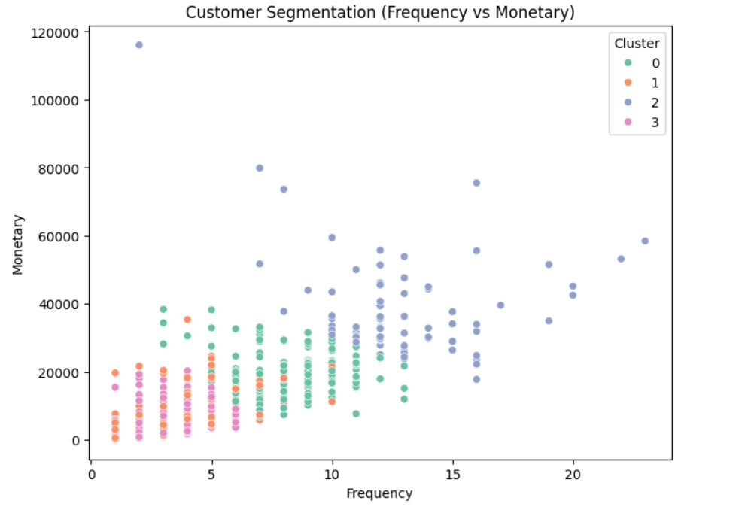
The plot shows that customers are grouped into distinct clusters, separating high-value frequent buyers from low-value occasional ones. This segmentation highlights that Cluster 2 contains the most profitable and loyal customers, while other clusters represent less engaged segments.

